Final Exam for Advertising Design Class: Instructor: Gary Olsen
Download the exam first, and save it to your hard drive or a personal directory. Save frequently, and when completed, attach it to an email to olsega@mchsi.com

Your Name: Score and Grade

1. The following elements on this outdoor sign mockup are movable with your mouse. Just click on the image, and you will see how items can be dragged and repositioned, even enlarged. Each item is an independent object including the background rectangle, the type element, the car and the logo. Items can be resized, but this is not absolutely necessary to make an effective design. The problem here is type. It’s totally inappropriate in terms of style, size, attitude and legibility. From fonts available to you on your computer pick a better font, position it in the black rectangle and size it without extending beyond the edges, and make a more effective composition of all elements within the sign’s format. When you click on the car, for example, you will see a little line with a green dot. This is a manipulator that allows you to change the angle of the car slightly if that’s helpful.
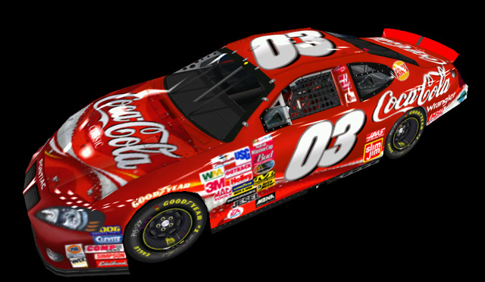
A Quick Refresher
2. What are two or more things that influence your personal taste in clothes, art, music and decorating? Please explain how this works.

B

3. You are approaching a new client on behalf of a brand development contract the firm wants you to work on for them. The concept is going to involve a logo, a packaging design, and lead to other projects involving several applications from outdoor advertising to retail space design. What are at least five things you must endeavor to learn in the process of discovery?


5. This ad appears in an important area journal designed to encourage people to consider Dubuque as a location for their business or a community to pursue one’s career and raise a family. How does this ad make use of at least five of the seven essentials of effective graphic design (at least five apply, so identify specific examples, please)?

6. What are the criteria that make a good logo or trademark? Provide at least three criteria and explain each of those criteria.

7. This test element requires proficiency in two areas, creativity and design. The photo below is an image for a poster design promoting the arts in schools. The message we are trying to convey is that the visual and performing arts make better students. Come up with a creative headline and position it on the photo in a place you deem most appropriate. You must select the appropriate type style and compose a line of text that will contrast effectively with the photo. The body copy of the ad has already been prepared for you, but it’s in a color that does not contrast effectively with the background, so it’s unreadable. It says, “Musicians are actually better at math. Performing artists have higher verbal skills. An educational curriculum without the arts is like having to eat potatoes every day and nothing else. Support the arts in schools or we’ll all get what we deserve. Potatoes.”

Simply click on the text boxes to make changes to the text elements (like color) and to reposition them. There’s no need to compose new or different copy, but be creative on the bold headline. To begin composing your headline and select text color from the Drawing Tools Palette in Microsoft Word, you may have to access the Tools menu and /Customize/Drawing to reveal the drawing tools on your screen if they are not visible. You can change the type size, but keep the style among the core group of fonts available on most if not all Windows computers.


Musicians are actually better at math. Performing artists have higher verbal skills. An educational curriculum without the arts is like having to eat potatoes every day and nothing else. Support the arts in schools or we’ll all get what we deserve. Potatoes.
Bold Headline
Text Element

- In project development there is a design stage and a production stage. In the design stage and there are three essential answers to questions critical in managing the process that puts your idea on a printed page, signage, garment, etc. Identify and describe each one of them briefly.

- In the production stage, you move the project from the design stage to production stage. To ensure success throughout the entire process, what are the three essential skills or objectives you must embrace? And describe what each of these mean.

10. The Seven Essentials of Graphic Design (your text book) are as follows. Answer the questions posed beneath each essential element.
Typography
BOLD, ANGULAR CAPITAL LETTERS SHOUT! while thin, curvy letters in upper-lower case whisper.
What are the five considerations when choosing type?

Contrast
Contrast makes your design visually appealing. What are the three ways you can organize contrast in your design?

Layout
Why is a proper layout important to the viewer?

Grid Systems
What is the reason for a grid system?

Identity Design: Logo & Logotypes
What is a key aspect of a proper logo or trademark design?

Critique and Analysis
Why is critique and analysis important to the designer and inevitably the client?

