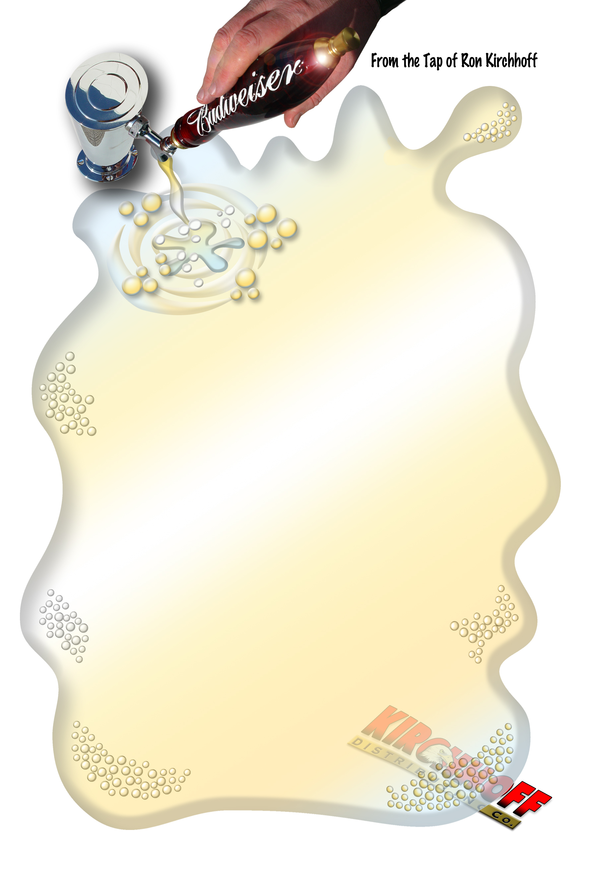
Type here
Type here
P.O. Box 692, Dubuque, Iowa 52004-0692 800-446-9058 Fax 563-556-8973
e-mail rkirchhoff@kdcbud.com

